Stroke Prediction

An Exercise in Machine Learning and Stroke Probability Predictions

Yakov Krasnikov

Charles Philpott

Troy Youngblood

**Executive Summary**

Cerebrovascular accidents (strokes) in 2020 were the 5th leading causeof death in the United States.

The objective of this activity was to develop a model which can reliably predict the likelihood of a stroke using patient input information.

**Hypothesis**

A reliable predictive model can be developed if the data and stroke key attributes are correctly identified and prepared for the machine learning process. The importance of features generated by the model selected will be compared against the stroke risk factors identified by the American Stroke Association. If the attributes are correctly identified by the model, the hypothesis will be considered validated.

**Data Selection**

A dataset from Kaggle was selected for the machine learning process. The data was reviewed to identify trends and cleanup requirements. The primary data cleanup activities identified were to address “N/A” values associated with body mass index and “Unknown” smoker status. The “N/A” values represented 3.9% of the dataset and were addressed by using the mean body mass index and assigning that to the “N/A” values. The “Unknown” smoker status represented 30.4% of the dataset. Literature review verified that “Unknown” values were considered an accepted data point and therefore the “Unknown” values were left as presented in the raw data.

**Data Preparation**

Review of the data identified most of the Yes/No type answers for personal health questions, including if the person had a stroke, were heavily biased to the “No” side. To ensure an effective model learning process, Synthetic Minority Oversampling Technique (SMOTE) was used to synthetically balance the Yes/No results for stroke. The No datasets for stroke that were most like the Yes datasets were temporarily converted to Yes for machine learning purposes. Other data preparation steps included One-Hot Encoding.

**Model Selection and Machine Learning**

Linear and Tree models were evaluated. The criteria used to select the model was one that did not overfit the data and had the best overall performance for f1-scores and recall for the likelihood of a stroke. After the evaluation process was completed, a Linear Model, LogisticRegression was selected. The results were saved and tested against live data after the model selection and machine learning process was completed.

**Hypothesis Validation**

The live testing of data verified that a reliable predictive model could be created if the data and stroke key attributes are correctly identified and prepared for the machine learning process.

Table of Contents

Introduction 4

Hypothesis 5

Data Source 5

Data Review 5

Visualizations 9

Data Preparation for Machine Learning 11

Data Cleaning and Imputation 11

Data Exploration 12

Correlation Heat Map 12

Addressing Data Bias 13

Machine Learning 14

Machine Models Evaluation 14

Linear Models 14

Tree Models 15

Model Selection 16

Final Model Run 16

Feature Importance 17

Conclusion 18

Hypothesis Validated 18

Trial Run Console Views 19

Actionable Items 19

Future Work 19

References 20

Introduction

The objective of this activity is to develop a preliminary screening tool which can be used to identify the likelihood of an individual having a stroke based on general contributing attributes. [Data](https://www.kaggle.com/fedesoriano/stroke-prediction-dataset) [1] from Kaggle was used as the basis for the predictive model.

Cerebrovascular accidents (strokes) in 2020 were the 5th leading causeof [death](https://www.cdc.gov/mmwr/volumes/70/wr/mm7014e1.htm?s_cid=mm7014e1_w#F1_down) [2] in the United States.

A stroke occurs when the blood supply to a region of the brain is suddenly blocked or when a rupture occurs starving the brain cells of oxygen and nutrients. Blockage obstructing the flow of blood to a region of the brain is called an ischemic stroke and accounts for [87%](https://www.stroke.org/en/about-stroke/types-of-stroke/ischemic-stroke-clots) [3] of all strokes. The rupturing of a blood vessel is called a hemorrhagic stroke and accounts for [13%](https://www.stroke.org/en/about-stroke/types-of-stroke/hemorrhagic-strokes-bleeds) [4] of all strokes.

Ischemic Stroke Hemorrhagic Stroke

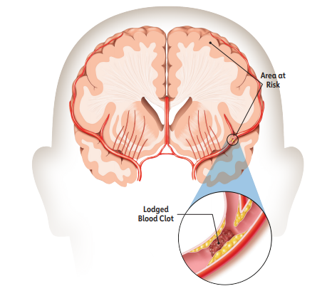 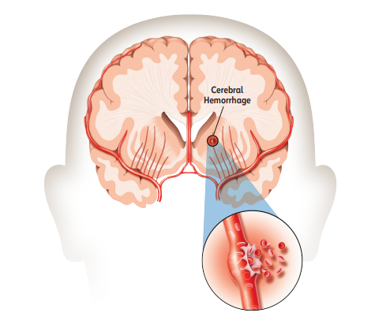

Source of [Images](https://www.stroke.org/-/media/stroke-files/stroke-resource-center/brochures/explaining_stroke_brochure_6_25_19.pdf?la=e) [5]

The dataset used for the predictive model did not identify the type of stroke for each respective individual. To stay consistent with the dataset, the general word stroke will be used to describe the occurrence being predicted. A third category of stroke called a transient ischemic attack (TIA), or "mini stroke", caused by a temporary clot can also occur. The TIA has contributing factors similar to those of the ischemic and hemorrhagic stroke and is included in the general term stroke when identifying a potential outcome.

Per the American Stroke Association, 80% of strokes are [preventable](https://www.stroke.org/en/about-stroke) [6].

Hypothesis

By using data associated with stroke victims, a predictive model will be developed to identify the likelihood of a stroke.

Hypothesis: A reliable predictive model can be developed if the data and stroke key attributes are correctly identified and prepared for the machine learning process. The importance of features generated by the model selected will be compared against the stroke risk factors identified by the American Stroke Association. If the attributes are correctly identified by the model, the hypothesis will be considered validated.

Basis Risk Factors from American Stroke Association common to the dataset.

* High Blood Pressure
* Smoking
* Diabetes
* Obesity
* Heart Disease
* Age (cannot be controlled)
* Gender (cannot be controlled)

Data Source

The attributes with the dataset are:

* id: a unique identifier for each set of information
* gender: “Male, “Female”, “Other”
* age: age of the patient
* hypertension: 0 assigned if hypertension not present, 1 if patient has hypertension
* heart_disease: 0 assigned if heart disease not present, 1 if patient has heart disease
* ever_married: “No” or “Yes”
* work_type: “children”, “Govt_job”, “Never_worked”, “Private”, or “Self-employed”
* Residence_type: “Rural” or “Urban”
* avg_glucose_level: average glucose level in blood
* bmi: body mass index
* smoking_status: “formerly smoked”, “never smoked”, “smokes”, or “Unknown”
* stroke: 0 if patient has not had a stroke, 1 if patient has had a stroke

## Data Review

The raw dataset for machine learning consists of 5110 unique rows. Each row contains patient information designated by a unique id.

There were 2,994 (58.60%) “Females”, 2,115 (41.40%) “Males” and 1 “Other” in the gender attribute. The “Other” gender was dropped from the dataset for a resulting dataset of 5,109 unique rows.

|  |  |  |  |  |
| --- | --- | --- | --- | --- |
| Data Review | | | | |
| Data Attribute | Female | | Male | |
| Count | Percent of gender | Count | Percent of gender |
| Had a stroke (Y) | 141 | 4.7 % | 108 | 5.1 % |
| Considered diabetic risk | 230 | 7.7 % | 204 | 9.6 % |
| Have heart disease (Y) | 113 | 3.8 % | 163 | 7.7 % |
| Have hypertension (Y) | 276 | 9.2 % | 222 | 10.5 % |
| Considered obese | 1,115 | 37.2 % | 805 | 38.1 % |
| Married (Y) | 2,001 | 66.8 % | 1,352 | 63.9 % |
| Live in Urban areas (Y) | 1,529 | 51.1 % | 1,067 | 50.4 % |
| Never smoked | 1,229 | 41.0 % | 663 | 31.3 % |
| Formerly smoked | 477 | 15.9 % | 407 | 19.2 % |
| Currently smoke | 452 | 15.1 % | 337 | 15.9 % |
| Unknown smoking status | 836 | 27.9 % | 708 | 33.5 % |
| Age: 0-19 | 480 | 16.0 % | 486 | 22.9 % |
| Age: 20-39 | 791 | 26.4 % | 412 | 19.4 % |
| Age: 40-49 | 450 | 15.0 % | 280 | 13.2 % |
| Age: 50-59 | 472 | 15.7 % | 362 | 17.1 % |
| Age: 60-69 | 352 | 11.8 % | 269 | 12.7 % |
| Age: 70-79 | 336 | 11.2 % | 233 | 11.0 % |
| Age: 80+ | 113 | 3.8 % | 73 | 3.4 % |

Trends identified in the dataset:

* 92% of strokes occur over the age of 50.

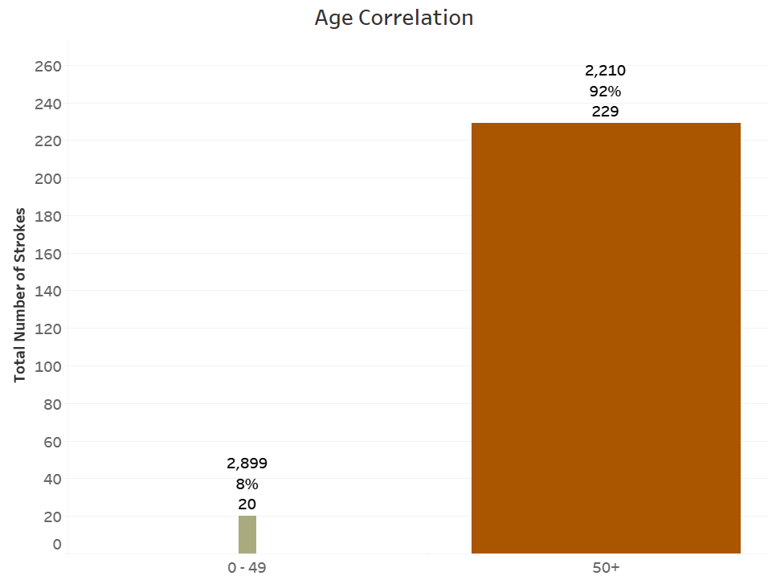

* The charts below are used to represent the general data characteristics defined by Yes/No answers. The attributes are in stacked panes for comparison purposes and the wider and darker brown bars indicate the higher normalized values.

Comorbidities Heart Disease and Hypertension, along with falling under Not Married generally have a higher percentage of strokes as age increases when the data is normalized for the specific age ranges.

The values associated with each bar are number of individuals in the designated age range, the normalized percentage of strokes in that range and the total number of individuals suffering a stroke in that range.

The lower Percentage of Not Married for Age Range 80+ could include individuals whose spouses have died and therefore where not married at the time of the stroke. The phrasing of the question and related answer could have inadvertently redirected the overall results for the age range.

Age Range 80+ generally has the highest percentage of strokes on a normalized basis.

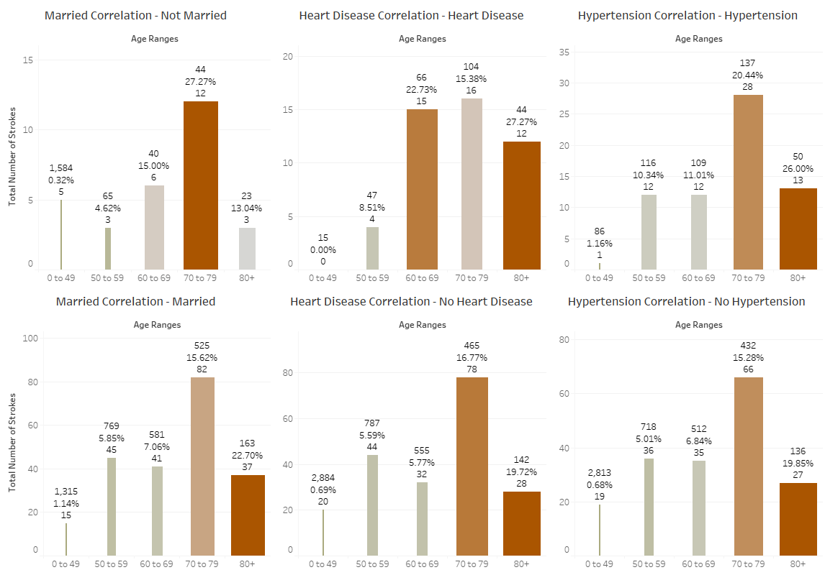

* Comorbidities BMI, Glucose (Blood Sugar) and Smoker Status data are represented in the chart below. BMI (Overweight and Obese), Glucose (Diabetic Risk and Diabetic) and Smoker Status (Formerly Smoked and Current Smoker) have the highest normalized stroke percentages. The wider and darker brown bars indicate the higher normalized values.

The BMI Categories for data visualization are:

* + Underweight: BMI < 18.5
  + Target: 18.5 <= BMI < 25
  + Overweight: 25 <= BMI < 30
  + Obese: BMI > 30

The glucose data presented in the dataset is average glucose value. Depending on when a person has eaten, a glucose value can have significant swings in values. Therefore, to create a Glucose Category that can used to filter the data, a blending of Fasting, Just Eaten and Several Hours after eating ranges were merged into ranges.

The Glucose Categories for data visualization are:

* + Hypoglycemic: average glucose <= 70
  + Target: 70 < average glucose < 140
  + Diabetic Risk: 140 <= average glucose <= 200
  + Diabetic: > 200

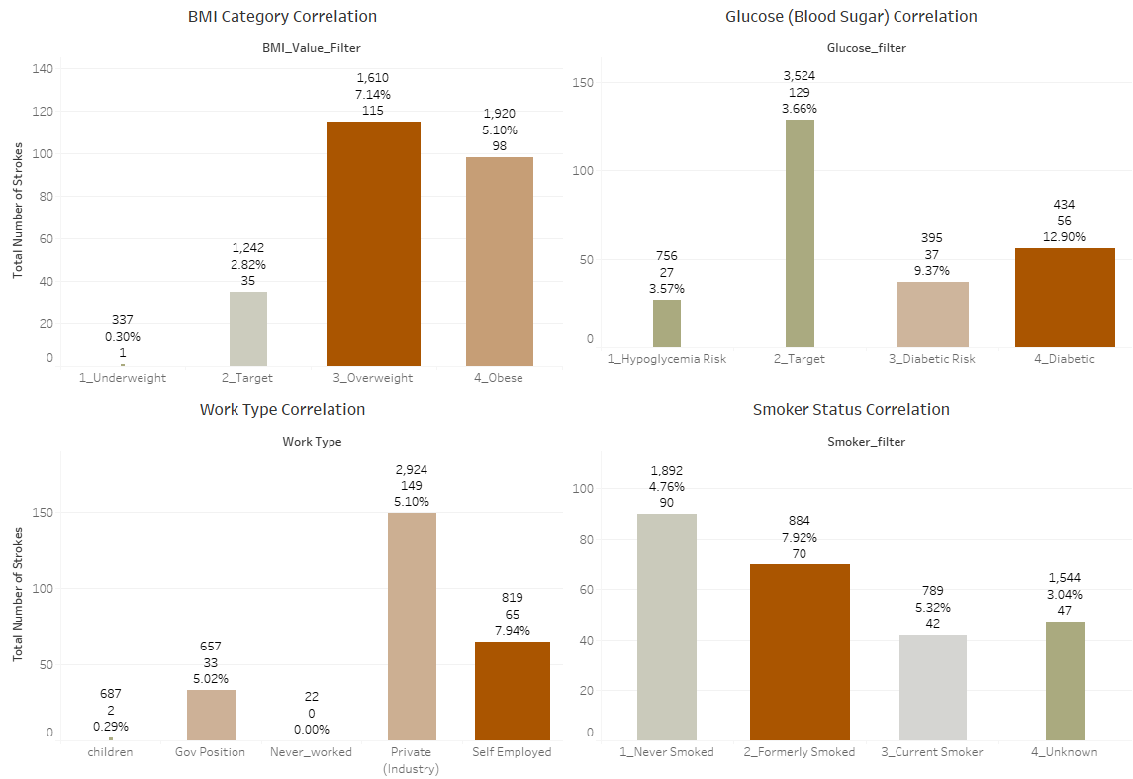

Visualizations

The data is represented in six different panes and one meet the data pane.

The main comorbidities are presented in five of the panes. The markers on each bar represents the total count, stroke total and stroke normalized percentage for the respective filter settings. The sixth pane lists gender, total count of the respective gender, total strokes, and stroke normalized percentage for the filter settings. The last pane is a bubble chart representing all the data in the dataset. When hovering over a bubble, information associated with the individual is presented.

All panes are tied into the filters and correspond with updated data after each selection.

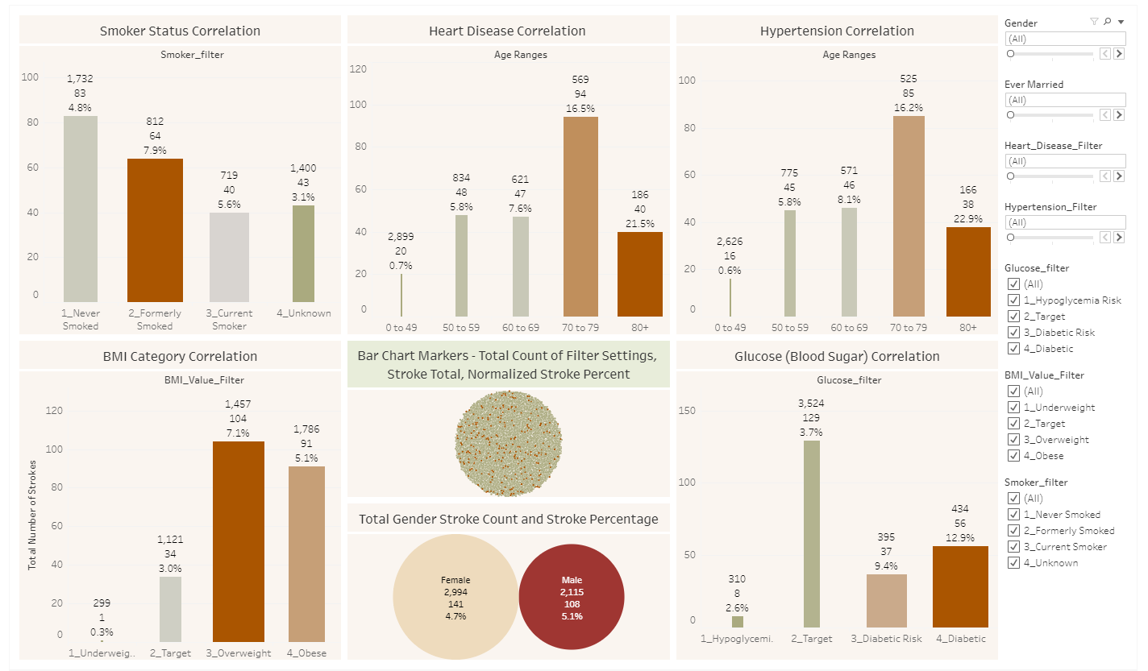

Additional data sources were used to supplement the stroke visualization effort. The data was used to create a map of stroke [mortality](https://data.world/us-hhs-gov/12ea7a13-b229-43b4-b19b-1459e9a64d3f) [7] (geographic location) and associated [statistics](https://www.ers.usda.gov/data-products/county-level-data-sets/download-data/) [8].

The map below combines information from both sources to create a tool to investigate stroke mortality rate along with ethnicity and average household median income.

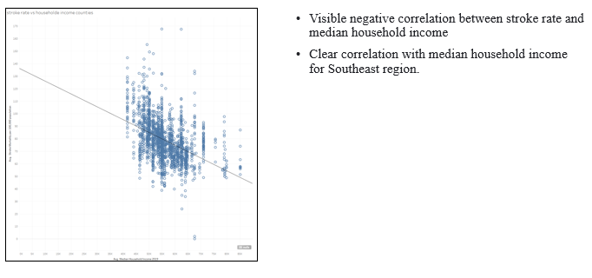

Data Preparation for Machine Learning

## Data Cleaning and Imputation

Data cleaning was conducted in Jupyter Notebook using Python.

As previously noted, the “Other” gender category was dropped from the dataset, resulting in removing 1 row of data.

In reviewing the raw data, the bmi attribute was identified as having 201 “N/A” values. This represents 3.9% of the dataset. The mean bmi value of 28.89 was used as the replacement value for the “N/A” values.

As noted above in the representation data tables, the raw dataset has a total 1,544 “Unknown” smoking status values representing 30.4% of the dataset. A closer look at the data showed 32% of the “Unknown” values were between the ages of 0-10 and 41% was between the ages of 0-15. The Centers for Disease Control and Prevention (CDC) defines a current [smoker](https://www.cdc.gov/nchs/nhis/tobacco/tobacco_glossary.htm) [9] as an Adult who has previously smoked 100 cigarettes in their lifetime and who currently smokes. Based on the CDC definition and the high percentage of “Unkown” values in the age range 0-10, it was originally discussed to replace those values with “never smoked”. Additional research of online literature to address this issue of “Unknown” labels was conducted and it was found that “Unknown” is an accepted category. The final decision was made to leave the “Unknown” smoker status values as presented in the raw dataset.

One-Hot Encoding was used for categorical data work_type and smoking_status to be used in the linear and tree models as shown below.

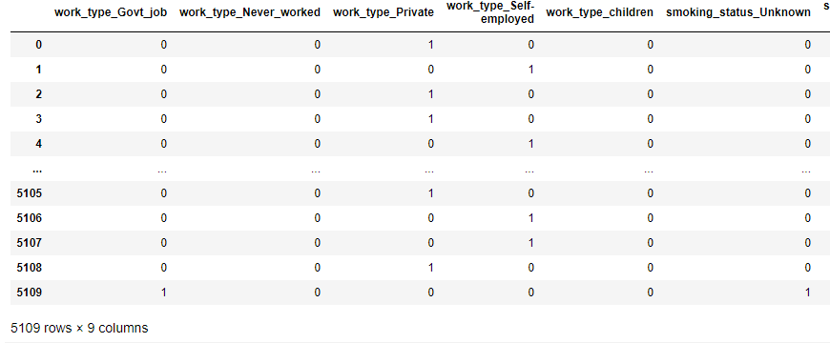

## Data Exploration

Most of the data was biased in the histograms, except for age and Residence_type. For the Yes/No questions, the data was left biased correlating to 0 which presents No as the answer to the respective question. The attributes bmi and average_glucose_level were left biased representing the lower end of their broad spectrum of data points.

Example histograms for age, bmi, average_glucose_level and stroke.

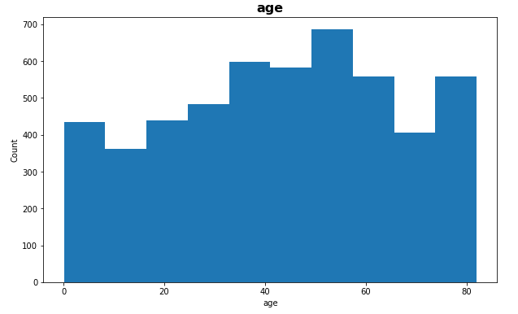 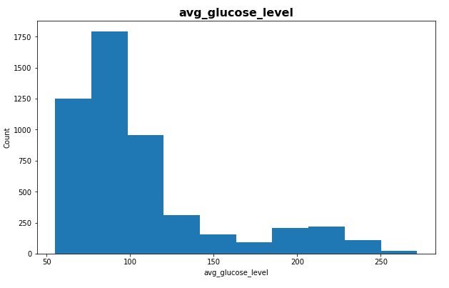

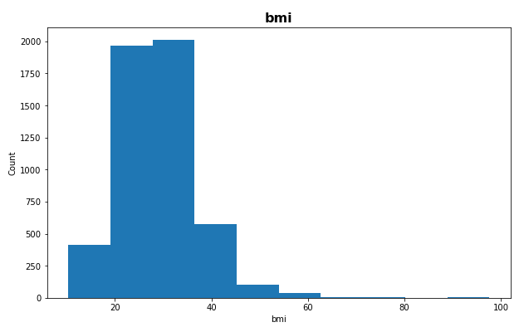 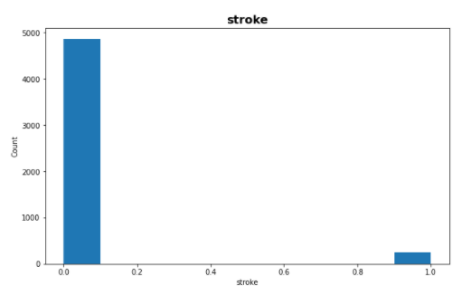

## Correlation Heat Map

The correlation heat map is presented below. Values closer to zero indicate minimal to no linear relationship. The more positively correlated attributes approach 1, meaning as one attribute increases so does the other. The more negatively correlated attributes approach -1, meaning as one attribute increases the other decreases.

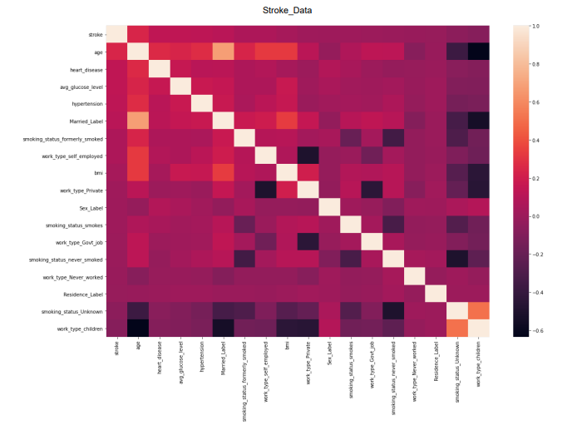

## Addressing Data Bias

There is a large imbalance of stroke incidents in the dataset. To improve the model learning capabilities, bias was addressed using Synthetic Minority Oversampling Technique (SMOTE) to temporarily adjust the percentage of stroke “Yes” values.

SMOTE utilizes k-nearest neighbor technique to create synthetic data. In this case, increase the number of stroke “Yes” values. SMOTE randomly chooses data from the stroke “Yes” values and then the respective k-nearest “No” neighbors. Synthetic “Yes” values are continually made until they closely match the “No” values. See before and after percentages below.

Stroke counts pre-SMOTE Stroke counts post-SMOTE

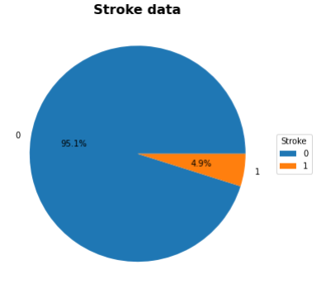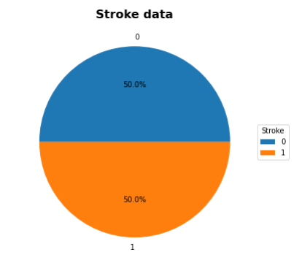

Machine Learning

## Machine Models Evaluation

The primary objectives of the model evaluation process were to identify a model that did not overfit the data, generated the highest f1-score for 1 (“Yes” for stroke) and generated the highest recall for “Yes”. The large number of 0 values (“No” for stroke), ensured a good f1-score for 0, but our objective was to identify a model that will give the best “Yes” result. That presented a challenge for the models. As noted above, SMOTE was used to help with this issue.

## Linear Models

Models evaluated were LogisticRegression, KNeighborsClassifier and Support Vector Machines (svm). The class_weight = “balanced” parameter was set for LogisticRegression and svm. The n-neighbors = 20 parameter was set for KNeighborsClassifier.

The best results for the linear model was LogisticRegression with an Out Sample f1-score of 0.23. KNeighborsClassifier and svm gave 0.16 and 0.19, respectively.

Model Evaluation Report for LogisticRegression.

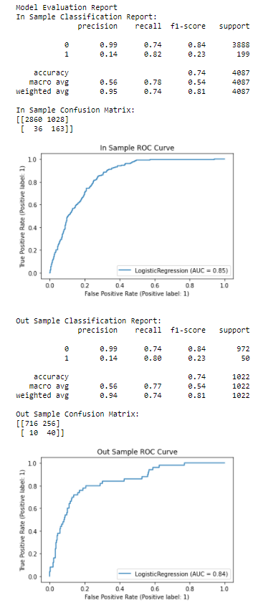

## Tree Models

Models evaluated were DecisionTreeClassifier, RandomForestClassifier, AdaBoostClassifier, GradientBoostingClassifier and XGBClassifier. The random_state = 42 parameter was set for each tree model. The n_estimators = 1000 parameter was set for RandomForestClassifier, AdaBoostClassifier and GradientBoostingClassifier. The use_label_encoder = False parameter was set for XGBClassifier.

The best results for the tree models were AdaBoostClassifier and GradientBoostingClassifier with Out Sample f1-scores of 0.24 and 0.26, respectively. DecisionTreeClassifier, RandomForestClassifier and XGBClassifier gave 0.13, 0.16 and 0.14, respectively.

Upon further evaluation, AdaBoostClassifier and, GradientBoostingClassifier gave recall values of 0.30 and 0.20. In each case, the models had a high value of missed 1 (“Yes” for Stroke) in the Out Samples.

AdaBoostClassifier GradientBoostingClassifier

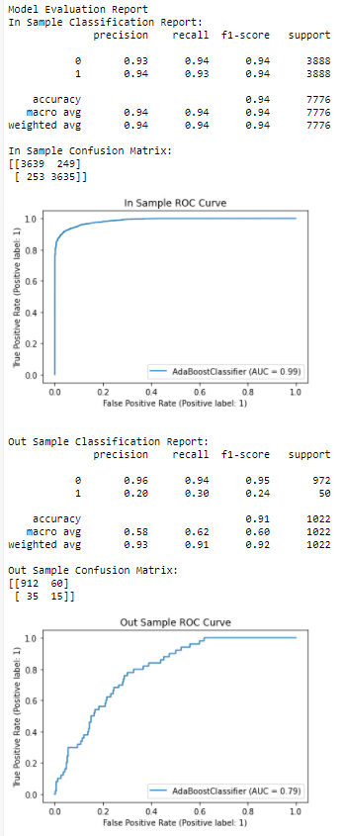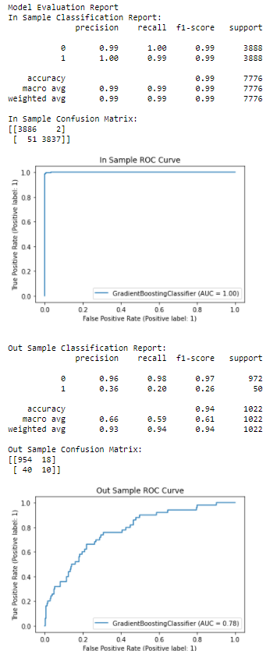

Model Selection

When reviewing the best of the respective Liner and Trees models, the Tree models had the best f1-scores, but extremely poor recall values. Therefore, the Liner model was selected with a little lower f1-score, but much better recall value.

|  |  |  |  |
| --- | --- | --- | --- |
| Model | LogisticRegression | AdaBoostClassifier | GradientBoostingClassifier |
| Model Type | Linear | Tree | Tree |
| f1-score (1) | 0.23 | 0.24 | 0.26 |
| Recall (1) | 0.80 | 0.30 | 0.20 |
| Selection | Yes | No | No |

## Final Model Run

LogisticRegression was run with class_weight = balanced, max_iter = 1000 and random_state = 42.

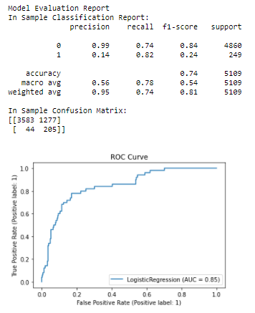

## Feature Importance

Feature importance is presented below. The chart presents the assigned value of the relationship between stroke and identified attribute. Like the correlation heat map, the values closer to zero indicate minimal to no linear relationship. The more positively correlated attributes approach 1, meaning as one attribute increases so does the other. The more negatively correlated attributes approach -1, meaning as one attribute increases the other decreases.

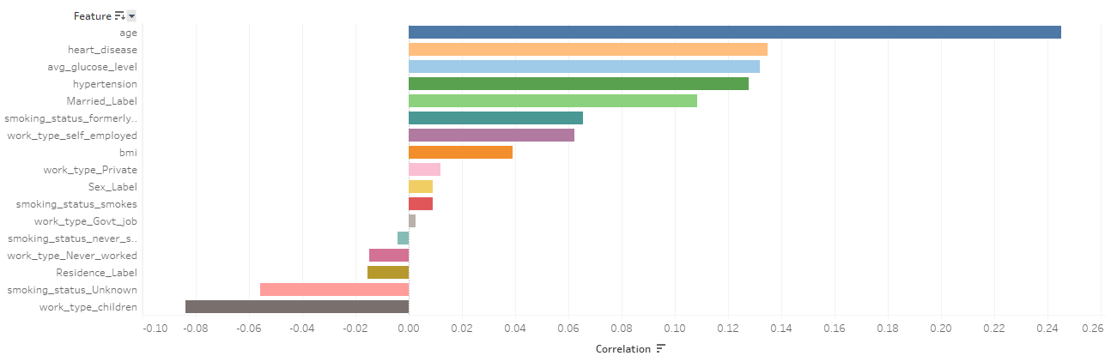

Conclusion

Objective: To determine if a reliable model was developed, the risk factors identified by the American Stroke Association will be compared against the Features Importance table and live data will be tested.

Revisiting the Hypothesis criteria

Basis Risk Factors from American Stroke Association common to the dataset.

* High Blood Pressure
* Smoking
* Diabetes
* Obesity
* Heart Disease
* Age (cannot be controlled)
* Gender (cannot be controlled)

## Hypothesis Validated

The top eleven in the Feature Importance chart with associated scores are:

* Age – 0.2452
* Heart disease – 0.1349
* Diabetes (avg_glucose_level) – 0.1320
* High Blood Pressure (Hypertension) – 0.1279
* Married – 0.1083 - this feature was picked up by the model because of the high difference between married / not married bias in the raw data. When the data was normalized, single had the higher stroke percentages.
* Smoking (smoking_status_former – 0.0655 & smoking_status_smokes – 0.0089)
* work_type_self-employed – 0.0622 & work_type_Private – 0.0119 - an adder of stress
* Obesity (bmi) – 0.0389
* Gender – 0.0091

The risk factors from the American Stroke Association have been identified in the Feature Importance chart with positive values.

Testing of the model provides expected results as more comorbidities are added.

## Trial Run Console Views

Trial 1 Trial 2

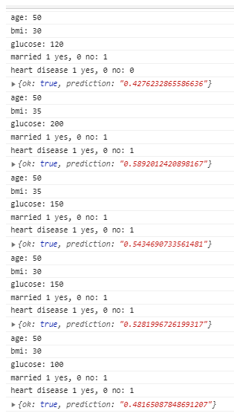 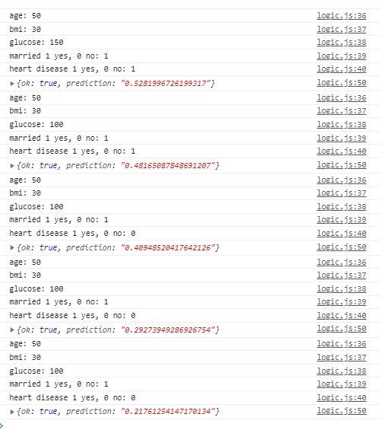

Actionable Items

This model is one of many tools which are needed to increase awareness and help reduce stroke incidents. As the noted above, the American Stroke Association states that 80% of strokes are preventable.

Actionable item

* Support stroke prevention awareness programs
  + Exercise
  + Eating correctly
  + Programs to stop smoking

Future Work

Periodic review and update of the model would be beneficial in creating a more successful tool.

References

[1] Stroke Prediction Dataset, *11 clinical features por predicting stroke events*, <https://www.kaggle.com/fedesoriano/stroke-prediction-dataset>

[2] Ahmad FB, Cisewski JA, Miniño A, Anderson RN. Provisional Mortality Data — United States, 2020. MMWR Morb Mortal Wkly Rep 2021;70:519–522. DOI <https://www.cdc.gov/mmwr/volumes/70/wr/mm7014e1.htm?s_cid=mm7014e1_w#F1_down>

[3] American Stroke Association, <https://www.stroke.org/en/about-stroke/types-of-stroke/ischemic-stroke-clots>

[4] American Stroke Association, <https://www.stroke.org/en/about-stroke/types-of-stroke/hemorrhagic-strokes-bleeds>

[5] American Stroke Association, *Explaining Stroke*, pages 1-20, <https://www.stroke.org/-/media/stroke-files/stroke-resource-center/brochures/explaining_stroke_brochure_6_25_19.pdf?la=en>

[6] American Stroke Association, <https://www.stroke.org/en/about-stroke>

[7] Stroke Mortality Data Among US Adults (35+) by State…2016, Dataset in U.S. Department of Health & Human Services, <https://data.world/us-hhs-gov/12ea7a13-b229-43b4-b19b-1459e9a64d3f>

[8] USDA Economic Research Service, U.S. Department of Agriculture, <https://www.ers.usda.gov/data-products/county-level-data-sets/download-data/>

[9] Centers for Disease Control and Prevention, National Center for Health Statistics, <https://www.cdc.gov/nchs/nhis/tobacco/tobacco_glossary.htm>